**WITHDRAW_MONEY Use Case Description: Main Flow**

|  |  |
| --- | --- |
| **User Action** | **System Response** |
| 1. User types in PIN into main screen | 1. System checks validity of PIN and presents options to user on another screen |
| 2. User selects “Withdraw Money” | 2. System presents withdrawable amounts or a field to enter the amount to withdraw on another screen |
| 3. User either enters or selects the amount among the options presented and presses enter | 3. System processes the transaction and if the transaction leaves the balance above the allowed minimum, the amount is dispatched, and a thank-you message is displayed on another screen. |

2.

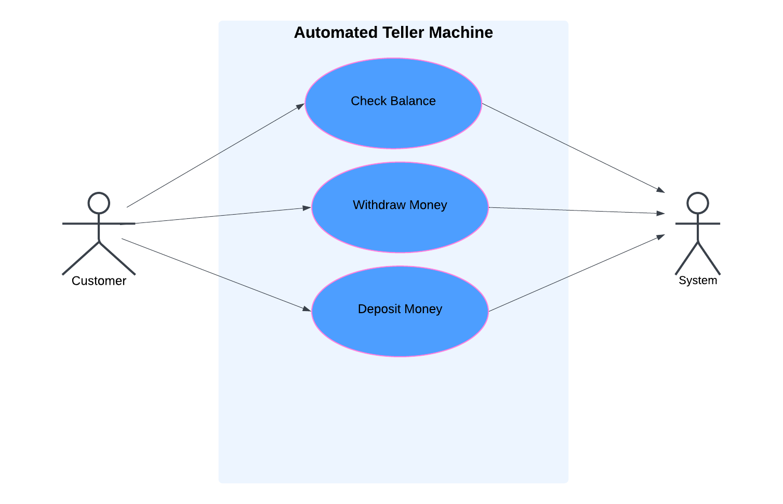

**3. The Project Management Tracking System**

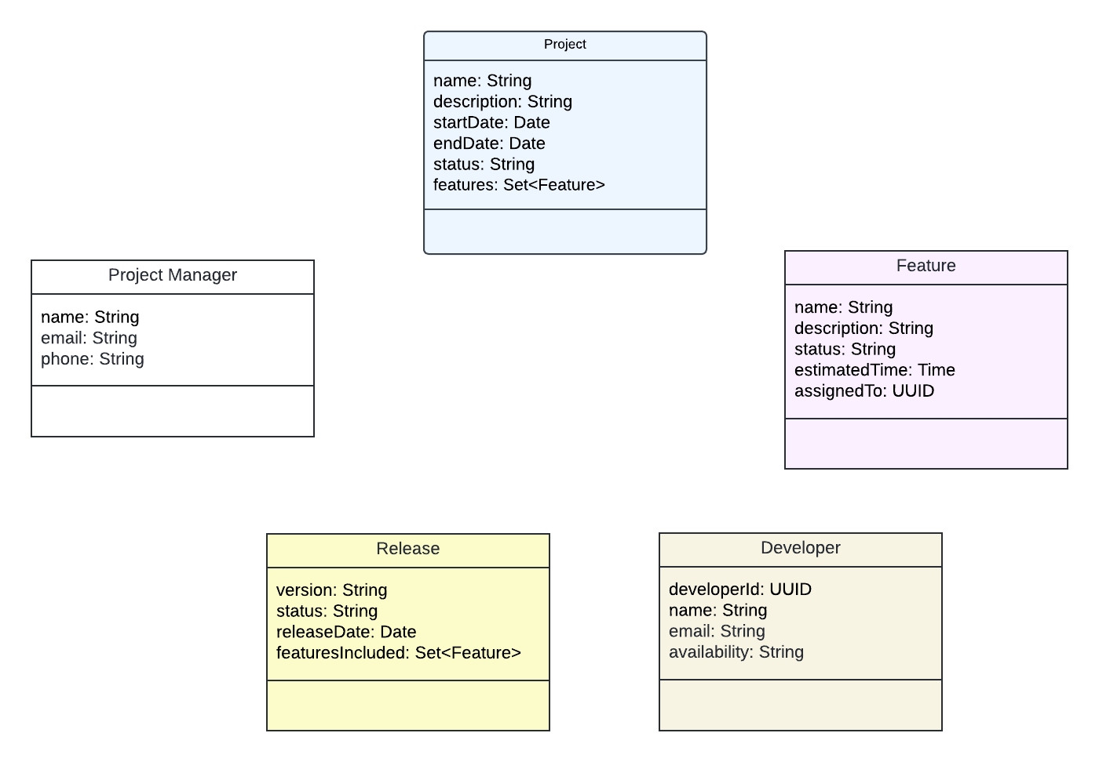

4. **Properties Management System**

